Assignment Part 2 C
Problem Statement :- Create an angular application which will do following actions: Register User, Login User, Show user data on profile component
For this assignment we need following softwares VS Code , Node JS and Angular CLI
Open VSCode then import one folder in VSCode
Now I will open the terminal in vscode. Make sure you have installed Node JS
Here I will type npm –version to ensure or verify whether node js has been installed or not.
Here I will create a project before that I have to install the angular cli, command for this is
npm install -g @angular/cli@latest
-g is generate
Now it will take sometime to install till that we will see what is angular? What are its benefit ? Why we are using it?
Angular JS is javascript based frontend framework and it is used to developing single page web applications.
It uses the HTML language as template language. Advantage with angular is that we have to write lesser code. IT uses the MVC i.e., Model-View-Controller Architecrture. It has directives and components.
Now our Angular Framework is installed in VScode to verify this we need to run ng - -version command.
After the installation of Angular now we will create an angular project with command ng new part_c it will create and dependencies required for any angular project . So lets wait for some time. Answer all the questions by selecting default options or questions.
A directory structure will be created under the part_c folder.
Till this happens we will write the code in part_c. Go to left pane click or expand the part_c then expand the src folder under that we have app component. Now inside app we are having some files the first file is app.component.css
Open the app.component.html file then after opening the file remove all the contents from the file by selecting and deleting the contents.
Now here what I will do is I will write one heading so that it means I am creating one registration form for that I am using h1 tag then two curly braces because we are binding the data component.ts file. Here I will write title. This title is a variable which we will create inside the app.compnent.ts and value for this will be assigned in the component.ts file only.

Now after h1 I have to create the form for that I will use input tag of html. Type input as text only. Using input tag after that we are using the id. Here we have declare the id using # hash #name this name will become my id for this input type equal to text. We can place the placeholder if wish else if you do not want to use then use label tag also.in placeholder I will write enter your name. Then I will use name attribute lastly I will use br tag
<input type="text" #name placeholder="Enter Your Name" name="name"> <br>
Now copy this whole line paste three times as we are going to use the address
<input type="text" #address placeholder="Enter Your Address" name="Address"> <br>
Here name will be using address and placeholder will have value Enter Your Address.
Next field I will be using is email and contact. I will write contact first as below.
<input type="text" #contact placeholder="Enter Your contact" name="contact"> <br>
Next line of code we will input type as email then
Here I have used input type as email and id I will use is email.
<input type="email" #email placeholder="Enter Your Email Address" name="email"> <br>
Same field I will copy here we will password and we have to change the input type as password.
<input type="password" #password placeholder="Enter Your Email Address" name="password"> <br>

Now we have created a form. Now we will create a button and pass these values inside this button.
So here I will create one button inside that parenthesis we will write click we have to call the method here.
Here we have to create a function in inverted commas. i.e., getvalue()
Here in parentheses we will pass the ids because here we have store the values and then display them.
<button (click)="getvalue(name.value, Address.value,contact.value, email.value)"> Register</button>d.
Next step is to open the app.component.ts file
Here title is part_c this value is binded to title tag from app.component.html file.
I will change title in app.component.ts to Registration form.
Now here we have to store the values of that input field for that we have to create some variables.
First variable I will create is displayname = ‘’ I will allocate the blank space
Then displayaddress=’’
displayname = '';
displayaddress='';
displaycontact='';
displayemail='';
four variables we have created successfully.
Now we have to call the function and get values.
We already have get values function then
Getvalues(name: the type of value this variable will hold,
getValue(name:string,address:string,contact:string,email:string)
After that we have to give curly bracket inside that curly bracket
Inside the curly brackets, we have to use this dot this variable name this.displayname = this name variable because we have to use this name variable inside our form.
this.displayname=name;
Similarly for all the remaining fields as
this.displayaddress=address;
this.displaycontact=contact;
this.displayemail=email;
Now we are done with component.ts file
Now we will be using this name i.e., this.displayname, this.displayaddress, this.displaycontact, this.displayemail variables to display our data because we have given the values by using the function.
Save this file contents. Again we will go back to our app.component.html file (first file).
We will add the line of code below button using h1 heading
<h1>Your registered data </h1> <br>
I will use the paragraph tag to display the individual fields p inside that we have to write Name Colon for calling that variable we have to use double curly brackets as
<p> Name : {{displayname}}</p>
<p>Address:{{displayaddress}} </p>
<p>Contact:{{displaycontact}}</p>
<p>Email:{{displayemail}}</p>

After this we have to ng -serve command from terminal in vscode
But before running this command we have to check the directory structure where we are standing now.
We are on Assignement 2 level but our code is in part_c
Now run the command ng serve command then I will hit enter.
It will compile your program and open in default browser.
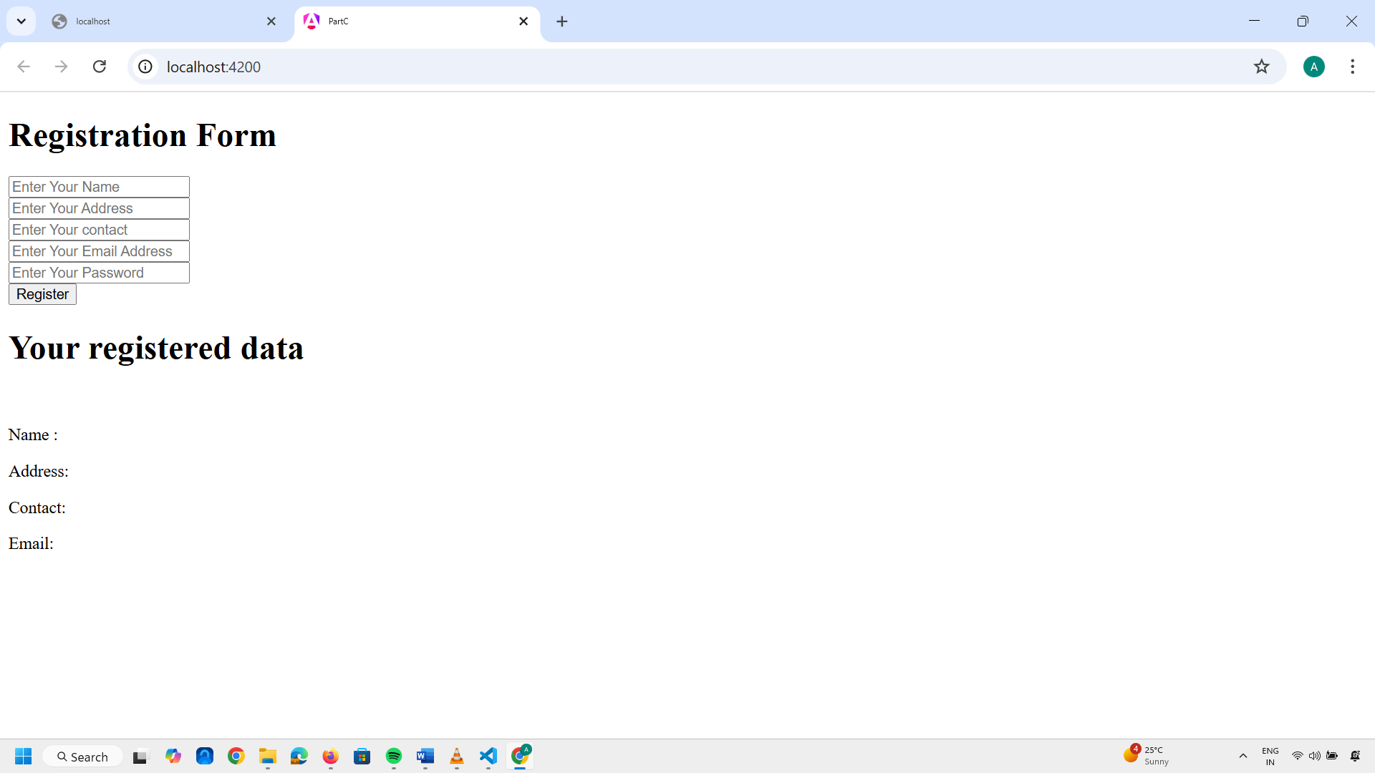
Now after entering the values or data clicking the Register button below. You can See Registered Data.
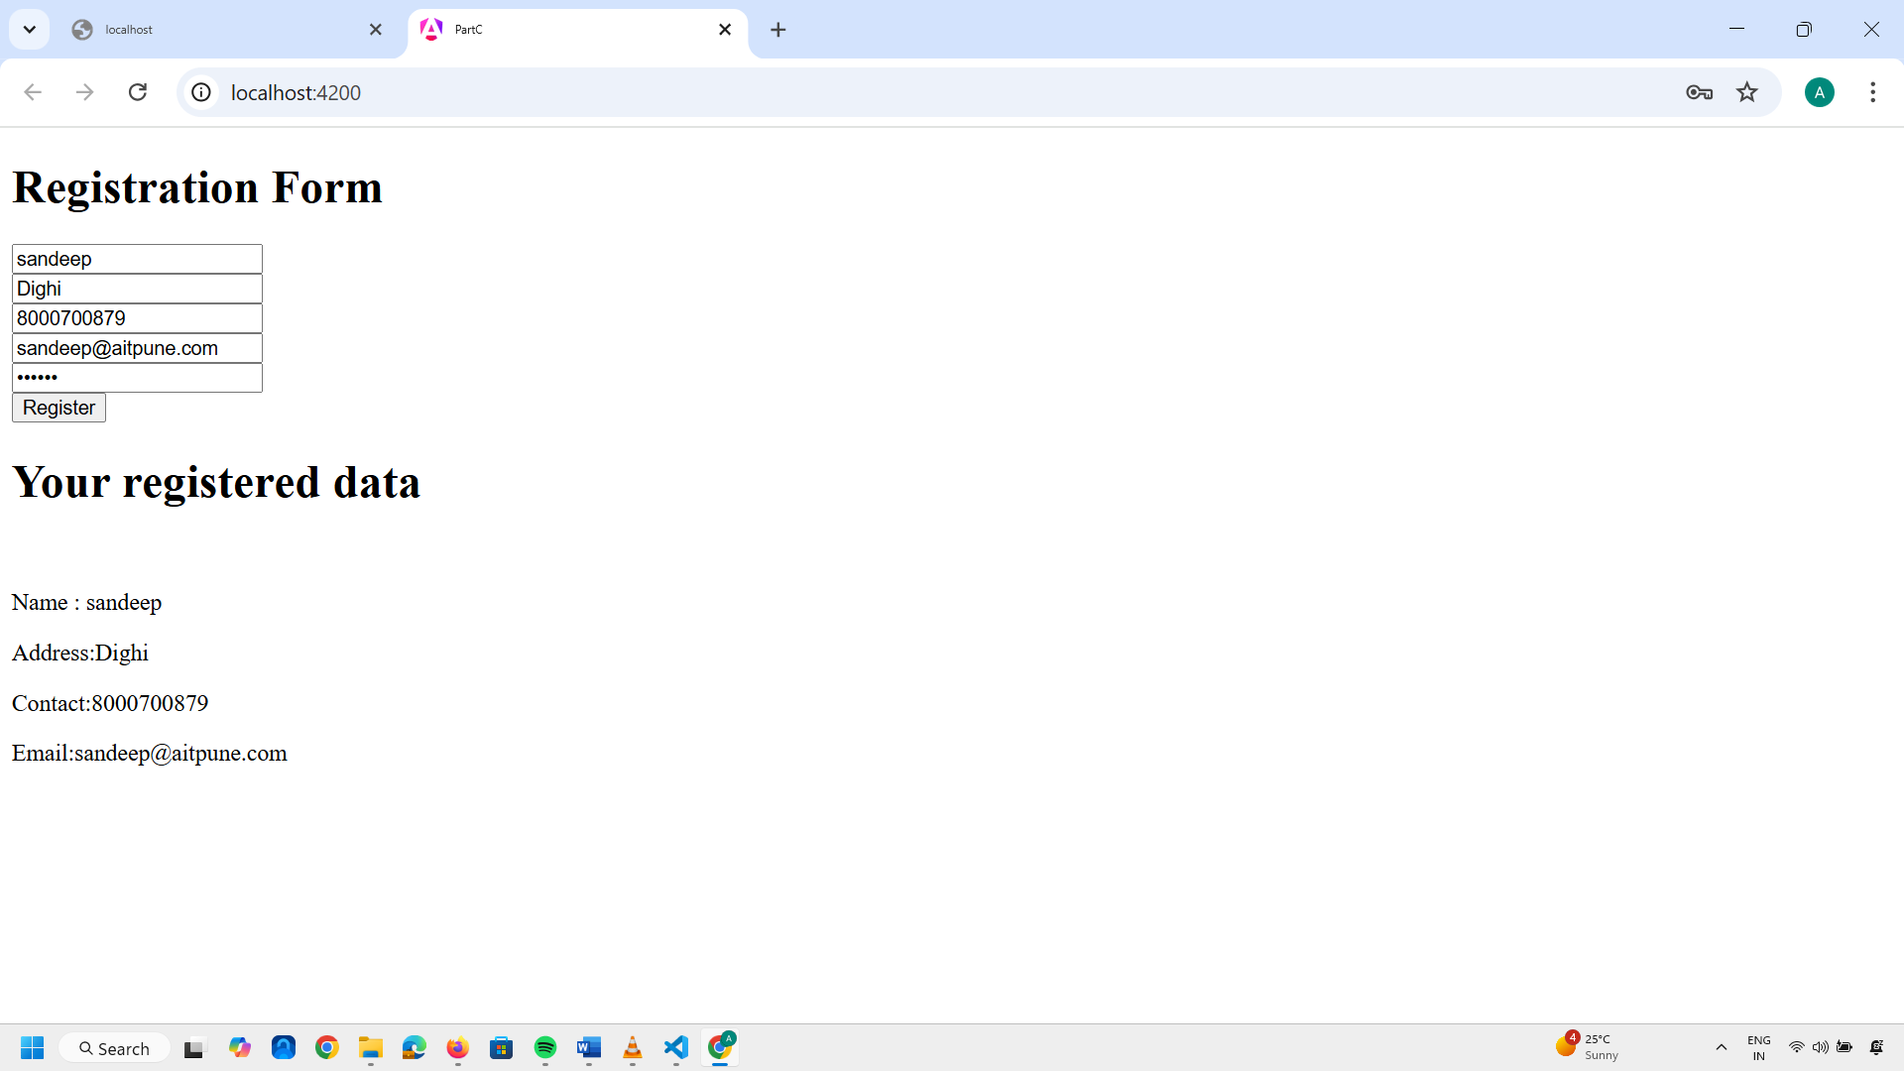

You can format this webpage by applying CSS. You can increase height and width of the input field.
You can apply the text color for this heading.
I will show you just the padding and margin to the input form.
Go to the VSCode editor. On Lefthand side pane see App.component.css file.
I will use css to my input tag. I will use width , height, margin and padding inside the css file of input field.
If you save the css file automatically it will compile the file and send it to the browser.

Now I want to add the css to the Register button as

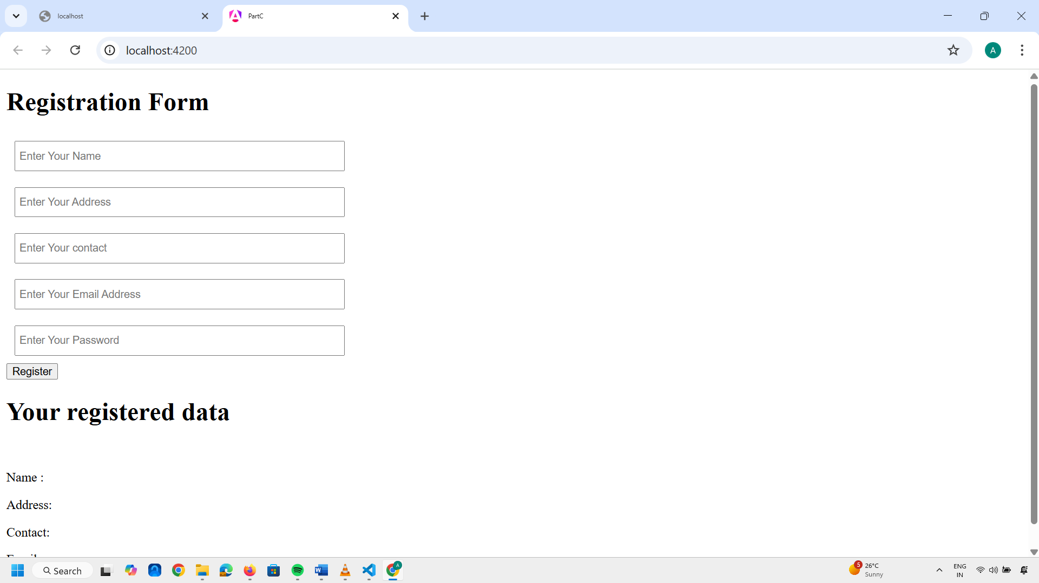

After adding the css to register button it will look something like this
